# Contributors

Nisa - dissolve effect

Paolo - beam and ground circle effects

# High Level Overview

When a player presses 1 or 2 on their keyboard, they time jump forwards or backwards respectively. This immediately triggers particle effects, which are made up of the following three effects:

* A rotating circle on the ground
* A particle beam around the player
* A dissolve effect that makes the player disappear and then reappear

When travelling forwards, these effects are coloured blue. When travelling backwards, they are coloured orange.

# Implementation

The keypress handler can be found in PlayerMovement.cs:keyControl(). When the user presses 1 or 2 this function then calls methods in ParticleController.cs.

For example, the StartJumpingForward() method is used to trigger the particle effects for jumping forward. It does this by setting a boolean animation parameter to true.

This is then used in the Player Animator Controller [1] (Assets->Resources->PlayerAnimation->Player). This parameter is the condition for transitioning from the Default state to the JumpForward state.

The JumpForward state has the JumpForward animation [2] attached (Assets->Resources->PlayerAnimation->JumpForward). Key frames have been set between 0 and 4 seconds to create the dissolve effect. They change values of the mesh renderers of the different body parts. Two events have also been set: one at the start and one at the end. The first event calls the ParticleController.cs:BlueBeam() function. The second event calls the ParticleController.cs:StopJumpingForward() function.

The BlueBeam() function sets the colours of the particle systems to be blue/white. It then calls the Play() method on the particle systems to activate them. Since these particle systems have looping unchecked in the inspector window in Unity Editor, they only play through once each time.

The StopJumpingForward() function resets the animation parameter to false. This causes the Player Animator Controller to transition back to the Default state.

The same process applies exactly to jumping backward.

# Screenshots

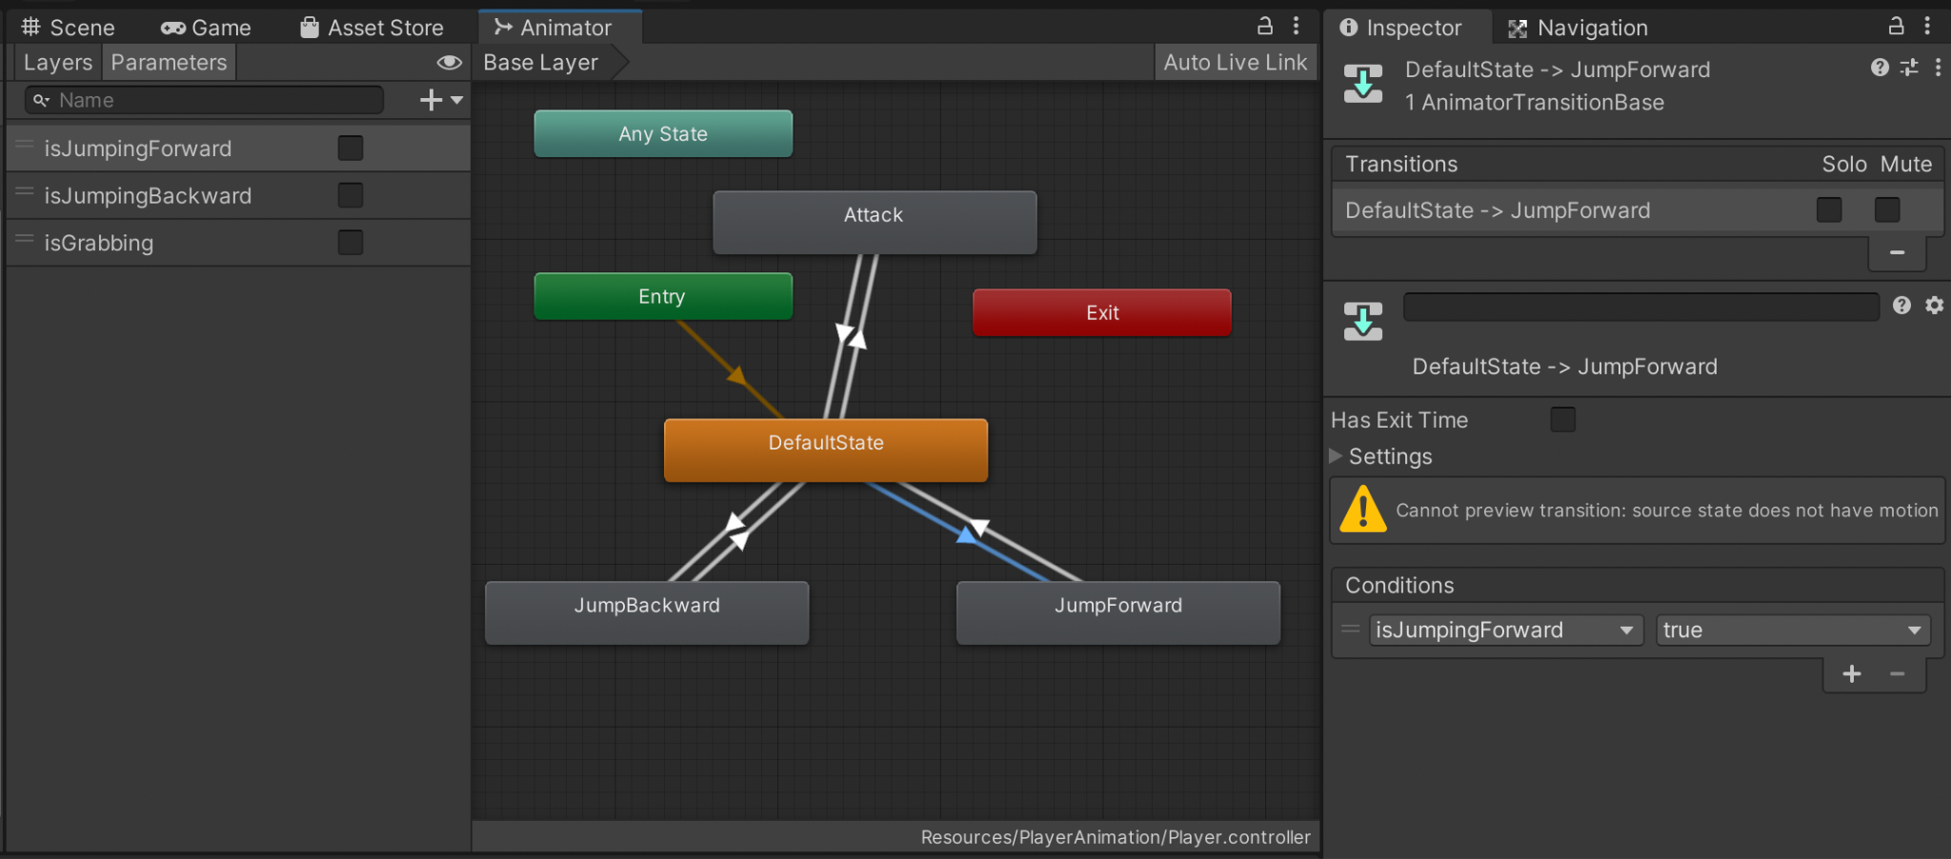

*Image 1: The Player Animator Controller. The animation parameters are in the list on the left. The state transitions are in the centre.*

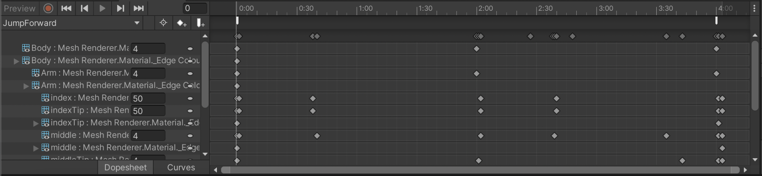

*Image 2: JumpForward Animation. The keyframes are the dots in the middle. The two white bars at the top are the events.*